TEACHER: MWALE CHI

KENNETH KAUNDA SECONDARY SCHOOL DESIGN AND TECHNOLOGY DEPARTMENT
LESSON PLAN

SUBJECT: DESIGN AND TECHNOLOGY CLASS:…… … DATE:……/……./20…. DURATION:………….
BOYS:…………………… GIRLS ………………………………………. TOTAL OF PUPILS… TOPIC: SURFACE DEVELOPMENT SUBTOPIC: CYLINDERS
LEARNING OUTCOMES LSBAT
- Construct surface development of plains Cylinders
RATIONALE
Knowledge: Development of: plain and truncated prisms plane and truncated cylinder
Skills: Manipulation, Accuracy,
Values: Appreciation, Application, Logical thinking, Problem solving, Quality work
TEACHING AIDS
……………………………………………………………………………………………………………………………………………

PART | LESSON CONTENT | METHODOLO GY | LEARNER ACTIVITY
introduction | - Recap on the previous lesson | Questions and answers | Provide answers
Development | SURFACE DEVELOPMENTOF PLAIN CYLINDER  To construct the development of the plains cylinder opening at j-j  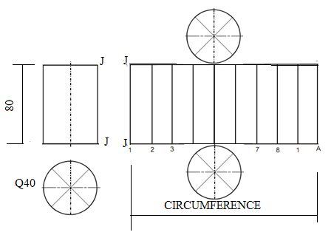  - Draw the plan and elevation of a cylinder. Height 80  - Divide the circumference in to twelve parts  - Project lines from the front elevation to obtain the height of the side  - Mark off equal units 12 from the plan circumference on extended base  - Add the circular top and bottom each diameter of 40 | Questions And Answers  Demonstration  V/E | Taking note of important points  Provide answers
Application | CLASS EXERCISE  construct the development of the plains cylinder opening at j-j height =80, diameter =40 mm. | Questions And Answers | Provide answers
Conclusion | - Recap on the main steps and points | V/E
LESSON EVALUATION

\

TEACHER: MWALE CHI

KENNETH KAUNDA SECONDARY SCHOOL DESIGN AND TECHNOLOGY DEPARTMENT
LESSON PLAN

SUBJECT: DESIGN AND TECHNOLOGY CLASS:…… … DATE:……/……./20…. DURATION:………….
BOYS:…………………… GIRLS ………………………………………. TOTAL OF PUPILS… TOPIC: SURFACE DEVELOPMENT SUBTOPIC: TRUNCATED CYLINDERS LEARNING OUTCOMES LSBAT
- Construct surface development of truncated Cylinders
RATIONALE
Knowledge: Development of: plain and truncated prisms plane and truncated cylinder
Skills: Manipulation, Accuracy,
Values: Appreciation, Application, Logical thinking, Problem solving, Quality work
TEACHING AIDS
……………………………………………………………………………………………………………………………………………

PART | LESSON CONTENT | METHODOLO GY | LEARNER ACTIVITY
introduction | - Recap on the previous lesson | Questions and answers | Provide answers
Development | SURFACE DEVELOPMENT OF TRUNCATED CYLINDER  To construct the development of the plains cylinder opening at j-j  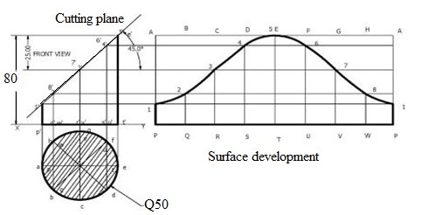  - Draw the plan and elevation of a cylinder. Height 80  - Indicate the cutting plane line at 300  - Divide the circumference in to twelve parts  - Project lines from the front elevation to obtain the height of the side  - Mark off equal units 12 from the plan circumference on extended base  - Add the circular top and bottom each diameter of 40 | Questions And Answers  Demonstration  V/E | Taking note of important points  Provide answers
Application | CLASS EXERCISE  construct the development of the plains cylinder opening at j-j height =80, diameter =40 mm. (D & T G9 Page 12) | Questions And Answers | Provide answers
Conclusion | - Recap on the main steps and points | V/E
LESSON EVALUATION

TEACHER: MR.MWALE

KENNETH KAUNDA SECONDARY SCHOOL DESIGN AND TECHNOLOGY DEPARTMENT
LESSON PLAN

SUBJECT: DESIGN AND TECHNOLOGY CLASS:…… … DATE:……/……./20…. DURATION:………….
BOYS:…………………… GIRLS ………………………………………. TOTAL OF PUPILS…
TOPIC: SURFACE DEVELOPMENT SUBTOPIC: PLAN AND TRUNCATED PRISM
LEARNING OUTCOMES LSBAT
- Construct surface development of plain and truncated prisms
RATIONALE
Knowledge: Development of: plain and truncated prisms plane and truncated cylinder
Skills: Manipulation, Accuracy,
Values: Appreciation, Application, Logical thinking, Problem solving, Quality work
TEACHING AIDS
……………………………………………………………………………………………………………………………………………

PART | LESSON CONTENT | METHODOLO GY | LEARNER ACTIVITY
Introduction | - Recap on the previous lesson | Questions and answers | Provide answers
Development | SURFACE DEVELOPMENT OF PLAIN AND TRUNCATED PRISMS  TO CONSTRUCT THE DEVELOPMENT OF THE PLAINS  PRISMS OPENING AT J-J  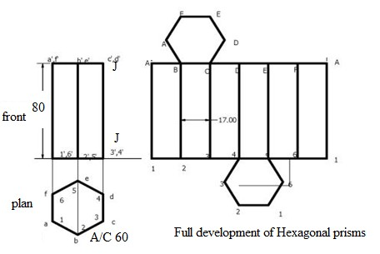
Application | CLASS EXERCISE  construct the development of the truncated hexagonal and prims  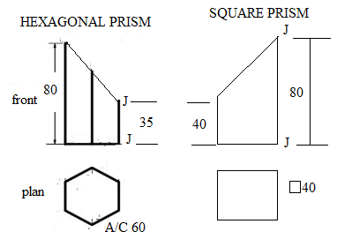 | Questions And Answers | Provide answers
Conclusion | - Recap on the main steps and points | V/E

TEACHER: MWALE CHI

KENNETH KAUNDA SECONDARY SCHOOL DESIGN AND TECHNOLOGY DEPARTMENT
LESSON PLAN

SUBJECT: DESIGN AND TECHNOLOGY CLASS:…… … DATE:……/……./20…. DURATION:………….
BOYS:…………………… GIRLS ………………………………………. TOTAL OF PUPILS…
TOPIC: SURFACE DEVELOPMENT SUBTOPIC: PLAN AND TRUNCATED PRISM
LEARNING OUTCOMES LSBAT
- Construct surface development of plain and truncated prisms
RATIONALE
Knowledge: Development of: plain and truncated prisms plane and truncated cylinder
Skills: Manipulation, Accuracy,
Values: Appreciation, Application, Logical thinking, Problem solving, Quality work
TEACHING AIDS
……………………………………………………………………………………………………………………………………………

PART | LESSON CONTENT | METHODOLO GY | LEARNER ACTIVITY
Introduction | - Recap on the previous lesson | Questions and answers | Provide answers
Development | SURFACE DEVELOPMENT OF PLAIN AND TRUNCATED PRISMS  TO CONSTRUCT THE DEVELOPMENT OF THE PLAINS  PRISMS OPENING AT J-J  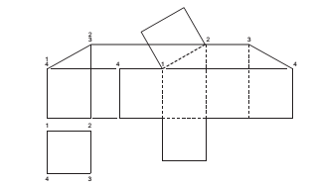
Application | CLASS EXERCISE  construct the development of the truncated hexagonal and prims | Questions And Answers | Provide answers
Conclusion | - Recap on the main steps and points | V/E

